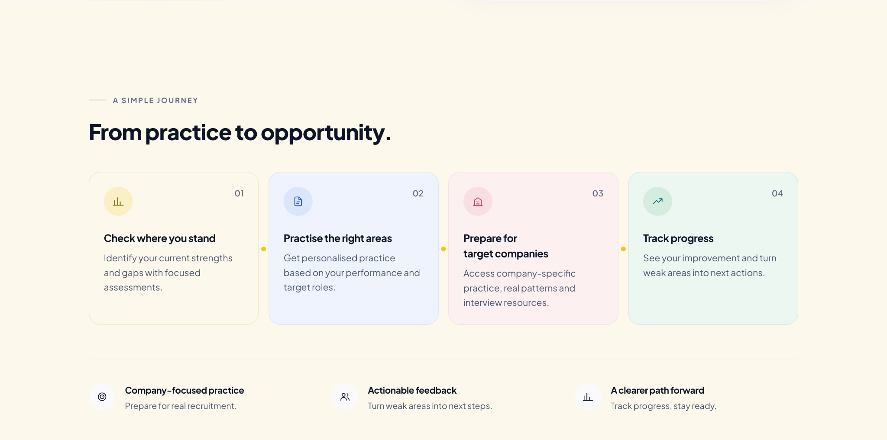
- Reduce Excessive Blank Space
  - There is too much unused vertical space above, within, and below this section.
  - Please reduce unnecessary padding and gaps so the section feels more compact and connected to the surrounding content.
  - The section should maintain enough breathing space, but it should not feel stretched.
- Make the prephasz Feature Cards More Visually Engaging
  - The current cards look too basic and can be presented in a more premium and visually strong way.
  - Please improve:
    - Card hierarchy
    - Icon treatment
    - Spacing and padding
    - Typography
    - Hover/interaction states
    - Alignment and consistency
  - Keep the visual language consistent with the rest of the website.
  - Avoid introducing too many colours.
- Add More prephasz Features
  - Please expand this section beyond the current four journey cards and include the following major features:
- Company-Specific Preparation
Prepare for companies like TCS, Accenture, Capgemini and more with focused resources and assessments.
Practice & Mock Assessments
Attempt topic-wise practice tests and full-length mock assessments built around placement patterns.
Performance Analytics
Track scores, accuracy, speed, strengths, weak areas and overall preparation progress.
Placement Readiness Score
Understand how placement-ready you are and identify exactly where you need to improve.
Live Masterclasses with SMEs
Learn directly from industry experts through aptitude, technical, soft-skills and company-focused sessions.
Personalised Study Plans
Follow structured preparation plans based on your goals, target companies and performance.
Jobs & Placement Opportunities
Discover relevant jobs, internships and placement opportunities directly on prephasz.
Resume & Interview Preparation
Build stronger resumes and prepare for interview rounds with guided tools and resources.
- Preferred Structure: Group Features into 6 Major Pillars
  - Instead of showing too many individual cards, a cleaner option would be to organise the platform into 6 major feature pillars.
- 1. Prepare
Company Hubs • Study Plans • Practice Questions • Topic & Section Preparation
2. Assess
Mock Assessments • Company-Specific Tests • Placement Readiness Tests
3. Analyse
Performance Dashboard • Section-Wise Analysis • Accuracy • Speed • Rankings
4. Learn
Live Masterclasses • SME Sessions • Recorded Resources • Explanations
5. Get Hired
Job Board • Resume Builder • Mock Interviews • Placement Opportunities
6. Track Outcomes
Certificates • Leaderboards • Student Reports • TPO Dashboard • Institutional Analytics
  - These can be shown as 6 premium cards in a 3 × 2 layout.
  - Each card should have:
    - One prominent icon
    - Pillar title
    - Short supporting line
    - Compact feature list
    - Subtle hover interaction
  - This approach is preferred because it presents the complete prephasz ecosystem without making the section too cluttered.
- Add a Strong Section Line
  - Please add this line prominently within the section:
- “Prepare. Practice. Assess. Improve. Get Placement Ready — all in one platform.”
  - This can sit below the main heading or above the feature cards as a concise summary of the platform journey.
- Overall Design Direction
  - The section should immediately communicate that prephasz is a complete placement preparation platform, not only a practice or assessment tool.
  - Keep the layout compact, visually strong and easy to scan.
  - Prefer the 6-pillar card approach over a long list of isolated feature cards.

